Thai Medical Desk — Prototype Functional Report
Oct 28, 2026 · @Mahi 3

Executive summary
Thai Medical Desk is a working, single-file prototype of an internal case-management and billing system for a medical-tourism business with offices in Bangladesh and Thailand. In a full test run on 28 Oct 2026, 40 of 42 checks behaved as designed, the other 2 confirmed known prototype limitations, and no application errors were raised. It is ready for a management demo and staff walkthrough, but not for real patient data: login, permissions, storage and file uploads are simulated inside one browser.
- What it does: tracks each patient from first inquiry to completion through 8 stages, with records, notes, follow-up tasks, hospital and Thailand travel details, and full patient billing.
- Who uses it: 5 role templates (Admin, Manager, Accounts, Coordinator, View only) built from 13 individual permissions.
- Billing: visa, air ticket, hotel, land package, service charges and discounts in BDT, THB or USD, with quotations, invoices, receipts, statements, supplier costs and estimated profit.
- Interface: Bengali and English, desktop and mobile.
- Before going live: a server backend is required for real logins, a shared database, secure file storage and a tamper-proof audit log.

How the review was done
The file (index 2.html) was opened in a headless Chromium browser and driven by a test script that signed in as each demo role and performed real operations through the interface. The run covered login, case creation, stage changes, notes, uploads, tasks, calendar, billing, invoicing, reversals, staff management, permissions, language switching, mobile layout and data persistence.
Demo ID | Role | Office | Used to test
STF-001 | Admin | Management | Every module, staff and permission changes
STF-002, STF-004 | Coordinator | Bangladesh, Thailand | Case work, notes, tasks, travel
STF-006 | View only | Bangladesh | Read-only access and blocked actions
STF-007 | Deactivated | Bangladesh | Blocked sign-in
STF-008 | Manager | Management | Accounts view and audit access
STF-009 | Accounts | Bangladesh | Billing entry and invoicing
All patient and staff data in the file is fictional demo data marked [DEMO].

Users, roles and permissions
Access is controlled by 13 individual permissions grouped into five areas; a role is only a template that ticks a preset set of them. Changing any single tick turns the role into "Custom", and staff belong to one of three offices: Bangladesh, Thailand or Management.
Permission | Admin | Manager | Accounts | Coordinator | View only
Create patient cases | Yes | Yes |  | Yes
Edit patient details and coordinator | Yes | Yes |  | Yes
Change case stage | Yes | Yes |  | Yes
View and download records | Yes | Yes | Yes | Yes | Yes
Upload records | Yes | Yes |  | Yes
Add communication and handover notes | Yes | Yes |  | Yes
Create and complete follow-up tasks | Yes | Yes |  | Yes
Edit hospital and appointment | Yes | Yes |  | Yes
Edit Thailand arrangements | Yes | Yes |  | Yes
View accounts, bills and balances | Yes | Yes | Yes
Add/edit financial entries, issue invoices | Yes |  | Yes
Add/edit staff and set permissions | Yes
View audit history | Yes | Yes
What each role sees in the left menu was confirmed in the run:
- Admin: Dashboard, Patient cases, Follow-up calendar, Accounts & billing, Staff, Audit history, System status.
- Manager: the same minus Staff; can view accounts but not post entries.
- Accounts: Dashboard, Patient cases, Calendar, Accounts & billing; cannot change cases.
- Coordinator: Dashboard, Patient cases, Calendar; no billing access.
- View only: sees cases and records; every edit button is hidden and the Accounts page is refused.
Safeguards that worked: deactivated and unknown staff IDs cannot sign in, a duplicate staff email is rejected, and an admin cannot remove their own staff-management permission.

Overall user flow
A case is opened by the Bangladesh team and moves forward one stage at a time; the Thailand office takes over hospital and travel work from stage 3, and the Accounts team bills from stage 4.
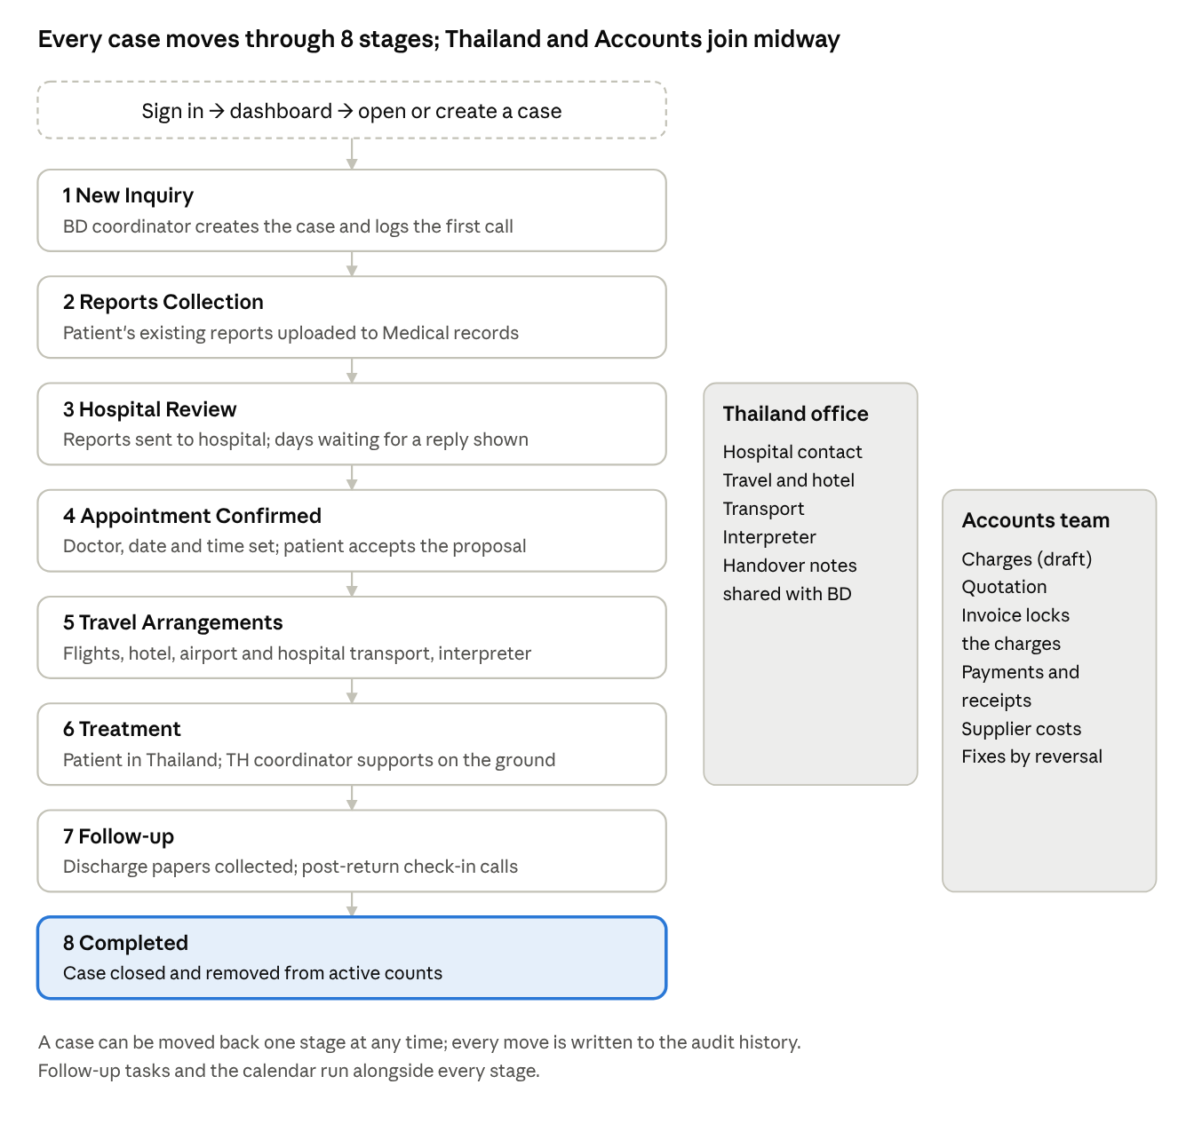
patient case flow · 8 stages, 2 supporting teams
A typical working day for a coordinator follows this loop:
- Sign in with a staff ID and land on the dashboard, which lists overdue and today's tasks first.
- Open a case from a task, the stage counters or search.
- Update the relevant tab: upload a report, log a call, edit hospital or travel details.
- Add a next action with a due date, which becomes a task on the calendar.
- Move the case to the next stage when its work is done.

Operations by module
The system has seven screens, and each patient case opens into seven tabs. Every change is written to the audit history with who did it and when.
Main screens
Screen | What staff can do
Dashboard | See active cases, today's follow-ups, overdue tasks and appointments in the next 30 days; jump to cases by stage; tick off tasks; view an accounts summary per currency
Patient cases | Search by name, case ID, phone (with or without spaces) or hospital; filter by stage, coordinator and office; create a case
Follow-up calendar | Month view of tasks, appointments, arrivals and departures, colour-coded; list view of overdue, today, next 14 days and recently completed; "Mine only" filter
Accounts & billing | Look up a patient account by case ID; totals per currency; balances by patient and by supplier; edit company details printed on documents
Staff | Add, edit, approve, deactivate or reactivate staff; tick permissions in a matrix
Audit history | Latest 300 actions with time, staff member, action and target
System status | Lists what is built, what is simulated and what needs a backend; reset demo data
Tabs inside a patient case
Tab | What it holds
Overview | Patient details, stated medical need, companion, assigned Bangladesh and Thailand coordinators
Medical records | Uploads grouped by document date; PDF, JPG or PNG up to 10 MB; category and uploader recorded
Communication | Phone, WhatsApp, email or in-person notes with outcome and next action; notes cannot be edited or deleted; a due date creates a task automatically
Hospital & appointment | Hospital, department, doctor, appointment, dates reports were sent and answered, proposal status; warns how many days a hospital reply is pending
Thailand assistance | Arrival and departure flights, accommodation, airport and hospital transport, interpreter, plus handover notes flagged when they come from the other office
Follow-up tasks | Tasks with owner and due date; overdue and today highlighted
Accounts & billing | The patient's billing account (next section); shown only to staff with accounts access
The system states on the case form that it does not provide diagnoses or treatment recommendations; medical needs are recorded "as stated by patient or family".

Accounting and patient billing
Every money entry is tied to the patient's case ID and kept in one invoice currency per patient (BDT, THB or USD). An entry can be in another currency, but staff must type the exchange rate, and the original amount and rate stay on record. Different currencies are never added together.
Charge types and how they are calculated
Charge | Inputs | Calculation
Visa fees | Visa category, travellers, unit fee, optional service charge | travellers × unit fee + service charge
Air ticket fees | Passenger, airline, route, dates, ticket ref, charge, optional service fee | charge + service fee
Hotel charges | Hotel, check-in, check-out, rooms, nightly rate | rooms × nights × rate (nights from the dates)
Land package | Airport transfer, hospital transfer, interpreter or other; quantity, unit rate | quantity × unit rate
Service charges | Description, amount | amount
Discounts | Description, amount | subtracted from the bill
Account flow
- Add charges; they start as Draft and can be edited or deleted.
- Generate a Quotation (an estimate) at any time.
- Issue invoice: all draft charges are numbered (INV-year-number) and locked.
- Record payments or refunds with method (cash, bank, bKash/Nagad, card, cheque) and reference; each gets a receipt number.
- Correct a locked entry by Reverse, which adds an equal and opposite entry with a reason; nothing is deleted.
- Print or save as PDF a quotation, invoice, receipt or full patient statement.
Internal figures (not printed for the patient): supplier costs and payments, supplier outstanding per supplier, and estimated profit = net patient charges − supplier costs.
Example from the demo data (case TMD-2026-0004, in USD): total bill USD 1,506.60, payments USD 549.00, balance due USD 957.60, supplier outstanding USD 526.40, estimated profit USD 585.20.
Two controls stood out in testing: a live preview shows the converted amount before saving (THB 1,000 at 0.028 = USD 28.00), and a warning appears when a land package marked "includes hotel" sits alongside a separate hotel charge, to prevent double billing.

Test results
42 checks were run: 40 behaved as designed and 2 confirmed limitations the prototype already declares (console editing and files lost on refresh). The page raised no script errors; the only console messages were web fonts that could not download in the offline test environment.
Area | Checks | Result | Key observations
Sign-in and dashboard | 5 | All passed | Deactivated (STF-007) and unknown IDs refused with clear messages; dashboard counts correct
Cases and search | 6 | All passed | New case got ID TMD-2026-0008; phone search works without dashes; stage forward and back logged
Notes, tasks, records | 4 | All passed | Note with due date created a task; .exe upload rejected; PDF accepted
Billing | 10 | All passed | FX preview correct; 3-decimal amount rejected; invoice locked its charges; locked charge could not be edited; reversal and double-billing warning worked
Staff and permissions | 6 | All passed | New Accounts user created; duplicate email refused; matrix tick switched role to Custom; deactivation worked
Role access | 7 | All passed | Each role saw only its menus; View only had no edit buttons and no Accounts page
Mobile, saving, security | 4 | 2 passed, 2 known limits | No sideways scroll at 390 px; data survived reload; console edit possible; uploaded file lost on reload
The Bengali interface was also switched on and displayed fully.
Issues found during review
# | Issue | Impact | Severity
1 | Any user can change data through the browser's developer console (a View-only user renamed a case) | Permissions are cosmetic until a server enforces them | High (expected in a prototype)
2 | Uploaded files disappear on page refresh; demo records have no real file | Records cannot be relied on | High (expected)
3 | Each staff browser keeps its own copy of the data | Bangladesh and Thailand staff do not see each other's work; invoice numbers can repeat across devices | High (expected)
4 | Opening "Quotation" as an accounts editor issues a new QT number every time, even just to look | Gaps and clutter in quotation numbering | Medium
5 | Supplier cost entries stay editable after the fact, unlike patient charges | Past costs and profit can change silently (the edit is logged) | Medium
6 | Estimated profit includes draft charges not yet invoiced | Profit can look higher than billed reality | Low
7 | System status page says "11 individual permissions"; the app has 13 | Documentation mismatch | Low
8 | Fonts load from Google Fonts | Offline the page falls back to system fonts; Bengali text still displays | Low

Limitations before real use
The prototype is honest about its limits: a banner on every screen says not to enter real patient information, and the System status page lists what is simulated. Real patient health and payment data must not go in until the items below are built.
Simulated today | What production needs
Sign-in by staff ID only, no password | Server sign-in with email invitations, passwords or magic links, and two-factor login
Permissions checked only in the browser | Permissions enforced on the server, with row-level security by role and office
Data saved in one browser's local storage | One shared database so both offices see the same cases in real time
Uploaded files held in memory until refresh | Private file storage with short-lived secure download links
Audit log stored in the browser and editable | Server-written, append-only audit log
Staff invitations send no email | Real invitation emails
Invoice numbers unique only per browser; no VAT or tax | Central numbering and tax rules if invoices are to be official
No WhatsApp or email link | Optional WhatsApp Business and email integration
Compliance: because the system will hold medical records, it must meet Thailand's Personal Data Protection Act (PDPA) and applicable Bangladesh data-protection rules, with backups and encryption. The file itself suggests Supabase (sign-in, Postgres database, private storage) as one practical backend.

Recommendations
Approve the prototype as the agreed design and move to a backend build; the screens and workflow are complete enough to serve as the specification.
- Now: run a staff walkthrough with demo data in both offices to confirm the 8 stages, fields and roles match daily work.
- Quick fixes in the file: issue a quotation number only when it is saved, not on every view; lock supplier costs once paid; show profit on invoiced charges separately from drafts; correct "11 permissions" to 13 on the status page.
- Phase 1 build: server sign-in, shared database, server-side permissions, private file storage and an append-only audit log.
- Phase 2: official invoice numbering and tax rules, email invitations, WhatsApp and email integration.
- Before go-live: a data-protection review against Thailand's PDPA and Bangladesh rules, backups, and a short user guide in Bengali and English.

